**Ecommerce – SQL**

create database ecommerce;

use ecommerce;

**SQL Tables:**

1. customers table:

• customer_id (Primary Key)

• name

• email

• password

1. products table:

• product_id (Primary Key)

• name

• price

• description

• stockQuantity

1. cart table:

• cart_id (Primary Key)

• customer_id (Foreign Key)

• product_id (Foreign Key)

• quantity

1. orders table:

• order_id (Primary Key)

• customer_id (Foreign Key)

• order_date

• total_price

• shipping_address

1. order_items table (to store order details):

• order_item_id (Primary Key)

• order_id (Foreign Key)

• product_id (Foreign Key)

• quantity

**Customer table:**

create table customers(

customer_id int primary key,

name varchar(50),

email varchar(200),

password varchar(50));

alter table customers

drop column password;

alter table customers

add column address varchar(500);

**Product table:**

create table products(

product_id int primary key,

name varchar(200),

price decimal(10,2),

description varchar(500),

stockQuantity int);

**Cart table:**

create table cart(

card_id int primary key,

customer_id int,

product_id int,

quantity int,

foreign key (customer_id) references customers(customer_id) ,

foreign key (product_id) references products(product_id));

**Order table:**

create table orders(

order_id int primary key,

customer_id int,

order_date date,

total_price decimal(10,2),

shipping_address varchar(500),

foreign key (customer_id) references customers(customer_id));

alter table orders

drop column shipping_address;

**Order items table:**

create table order_items(

order_item_id int primary key,

order_id int,

product_id int,

quantity int,

itemAmount decimal(10,2),

foreign key (order_id) references orders(order_id),

foreign key (product_id) references products(product_id));

insert into **customers** values

(1, 'john doe', 'johndoe@example.com', '123 main st, city'),

(2, 'jane smith', 'janesmith@example.com', '456 elm st, town'),

(3, 'robert johnson', 'robert@example.com', '789 oak st, village'),

(4, 'sarah brown', 'sarah@example.com', '101 pine st, suburb'),

(5, 'david lee', 'david@example.com', '234 cedar st, district'),

(6, 'laura hall', 'laura@example.com', '567 birch st, county'),

(7, 'michael davis', 'michael@example.com', '890 maple st, state'),

(8, 'emma wilson', 'emma@example.com', '321 redwood st, country'),

(9, 'william taylor', 'william@example.com', '432 spruce st, province'),

(10, 'olivia adams', 'olivia@example.com', '765 fir st, territory');

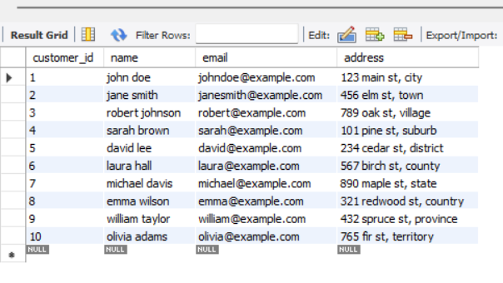

insert into **products** (product_id, name, description, price, stockQuantity)values

(1, 'laptop', 'high-performance laptop', 800.00, 10),

(2, 'smartphone', 'latest smartphone', 600.00, 15),

(3, 'tablet', 'portable tablet', 300.00, 20),

(4, 'headphones', 'noise-canceling', 150.00, 30),

(5, 'tv', '4k smart tv', 900.00, 5),

(6, 'coffee maker', 'automatic coffee maker', 50.00, 25),

(7, 'refrigerator', 'energy-efficient', 700.00, 10),

(8, 'microwave oven', 'countertop microwave', 80.00, 15),

(9, 'blender', 'high-speed blender', 70.00, 20),

(10, 'vacuum cleaner', 'bagless vacuum cleaner', 120.00, 10);

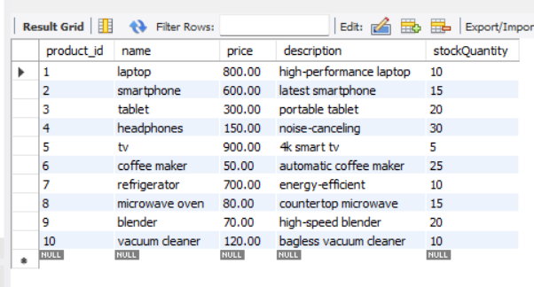

insert into **cart** (card_id, customer_id, product_id, quantity) values

(1, 1, 1, 2),

(2, 1, 3, 1),

(3, 2, 2, 3),

(4, 3, 4, 4),

(5, 3, 5, 2),

(6, 4, 6, 1),

(7, 5, 1, 1),

(8, 6, 10, 2),

(9, 6, 9, 3),

(10, 7, 7, 2);

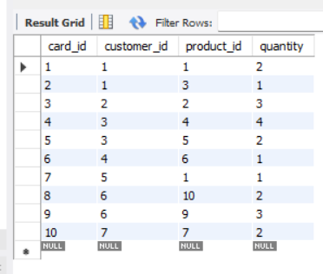

insert into **orders** values

(1, 1, '2023-01-05', 1200.00),

(2, 2, '2023-02-10', 900.00),

(3, 3, '2023-03-15', 300.00),

(4, 4, '2023-04-20', 150.00),

(5, 5, '2023-05-25', 1800.00),

(6, 6, '2023-06-30', 400.00),

(7, 7, '2023-07-05', 700.00),

(8, 8, '2023-08-10', 160.00),

(9, 9, '2023-09-15', 140.00),

(10, 10, '2023-10-20', 1400.00);

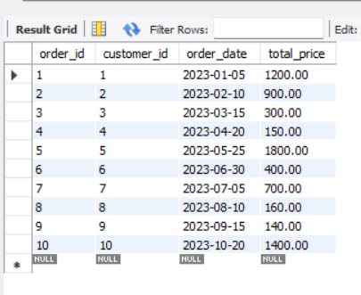

insert into **order_items** values

(1, 1, 1, 2, 1600.00),

(2, 1, 3, 1, 300.00),

(3, 2, 2, 3, 1800.00),

(4, 3, 5, 2, 1800.00),

(5, 4, 4, 4, 600.00),

(6, 4, 6, 1, 50.00),

(7, 5, 1, 1, 800.00),

(8, 5, 2, 2, 1200.00),

(9, 6, 10, 2, 240.00),

(10, 6, 9, 3, 210.00);

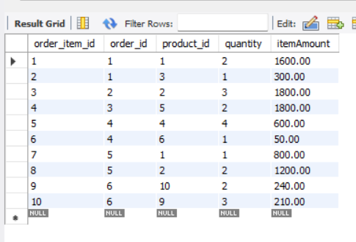

select * from customers;

select * from products;

select * from cart;

select * from orders;

select * from order_items;

**1. Update refrigerator product price to 800.**

update products

set price = 800.00

where product_id=7;

select name, price from products where product_id=7;

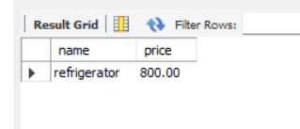

**2. Remove all cart items for a specific customer**

delete from cart

where customer_id = 6;

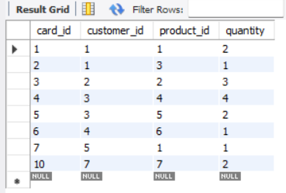

**3. Retrieve Products Priced Below $100.**

select * from products

where price<100;

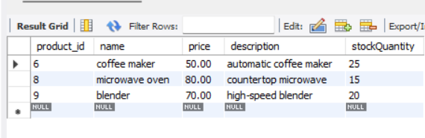

**4. Find Products with Stock Quantity Greater Than 5**

select * from products

where stockQuantity>5;

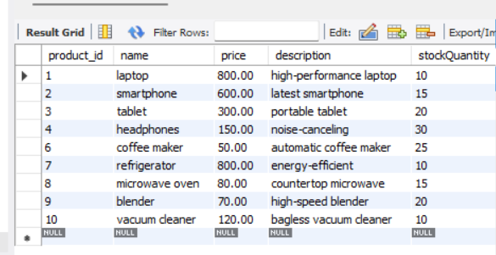

**5. Retrieve Orders with Total Amount Between $500 and $1000**.

select * from orders

where total_price between 500 and 1000;

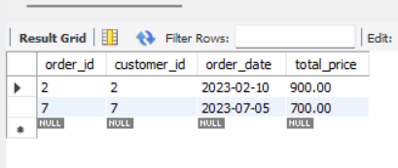

**6. Find Products which name end with letter ‘r’.**

select name from products

where name like "%r";

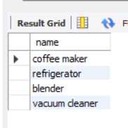

**7. Retrieve Cart Items for Customer 5.**

select * from cart

where customer_id = 5;

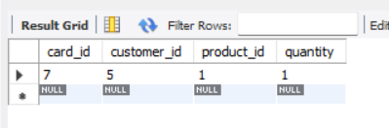

**8. Find Customers Who Placed Orders in 2023.**

select c.customer_id,c.name,c.email from customers c

join orders o on c.customer_id = o.customer_id

where year(o.order_date)=2023;

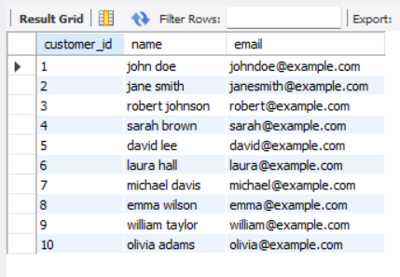

**9. Determine the Minimum Stock Quantity for Each Product Category**

alter table products

add column category varchar(100);

update products set category = 'electronics' where product_id in (1, 2, 3, 4, 5);

update products set category = 'appliances' where product_id in (6, 7, 8, 9, 10);

select category, min(stockQuantity) as min_quantity

from products

group by category;

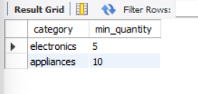

**10. Calculate the Total Amount Spent by Each Customer.**

select customer_id, sum(total_price) as total_amount

from orders

group by customer_id;

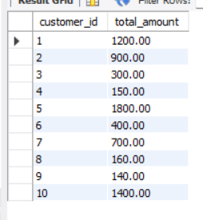

**11. Find the Average Order Amount for Each Customer.**

select customer_id, avg(total_price) as avg_amount

from orders

group by customer_id;

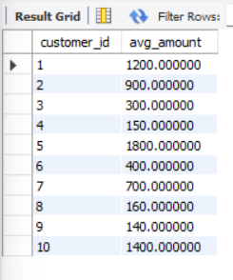

**12. Count the Number of Orders Placed by Each Customer**

select customer_id, count(order_id) as total_order from orders

group by customer_id;

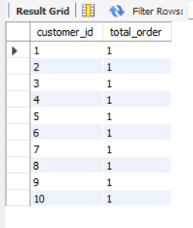

**13. Find the Maximum Order Amount for Each Customer**

select customer_id, max(total_price) as maxOrder_amount

from orders

group by customer_id;

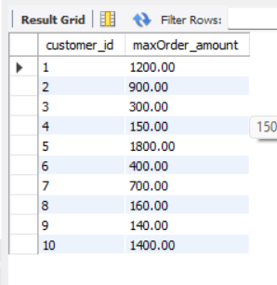

**14. Get Customers Who Placed Orders Totaling Over $1000.**

select c.customer_id,c.name,sum(total_price) as total_amount from customers c

join orders o on c.customer_id = o.customer_id

group by o.customer_id

having sum(total_price)>1000;

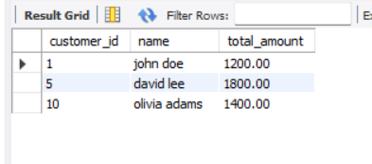

**15. Subquery to Find Products Not in the Cart.**

select product_id,name from products

where product_id not in

(select product_id from cart);

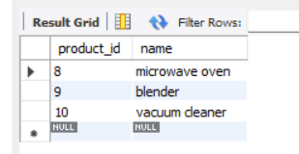

**16. Subquery to Find Customers Who Haven't Placed Orders.**

select customer_id, name,email from customers

where customer_id not in

(select customer_id from orders);

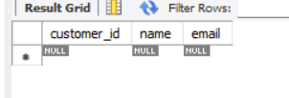

**17. Subquery to Calculate the Percentage of Total Revenue for a Product.**

select product_id, sum(itemAmount) as product_revenue,round(

(sum(itemAmount) * 100.0) /

(select sum(itemAmount) from order_items), 2) as revenue_percentage

from order_items

group by product_id;

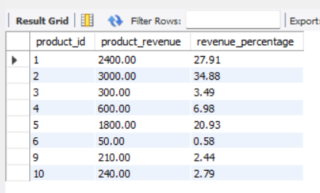

**18. Subquery to Find Products with Low Stock.**

select * from products

where stockQuantity < (select avg(stockQuantity) from products);

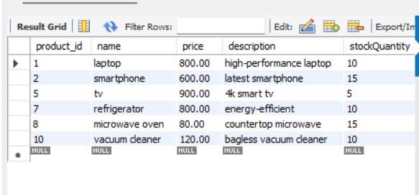

**19. Subquery to Find Customers Who Placed High-Value Orders.**

select *

from customers

where customer_id in

(select customer_id from orders where total_price > 1000);

